2BPHY: Electrical Fundamentals TEST 2010

Name: _____________________________________ (48 marks total)
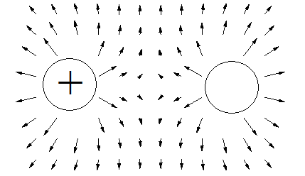
- The diagram shows two charged particles and the field that surrounds them. Using the information in the diagram determine the charge on the other sphere

_____________________
(1 mark)

- Which of the following graphs could represent an ohmic conductor? (1 mark)
Answer:

A B C D
- Calculate the resistivity of a metal alloy wire if a sample with cross-sectional diameter 0.200 mm and length 2.50 m has a measured resistance of 88.0 Ω. (3 marks)

4. A lightning bolt transfers 30.0 C of charge to the Earth through a potential difference of 2.00 x 10⁸ V. During this time, the lightning strike lasts for a time of only 1.50 ms.

a. How much energy is dissipated in this lightning strike? (2 marks)

b. What is the average power developed during the strike? (2 marks)

- The element of an electric jug has a resistance of 545 Ω and draws a current of 2.50 A. 750 mL of water at a temperature of 18.0⁰C is in the jug. How long will it take to bring the water to the boil (100⁰C)? (3 marks)

- The circuit diagram below shows a two-way switch wired to a single globe.

globe
Neutral

Active
Switch 1 Switch 2

With the switch positioned as shown, is the globe “on” or “off”? ___________ ( 1 mark)
Name a situation where you would use a two-way switch. __________________________ (1 mark)
- a. A force of 8.50 x 10⁻³ N attraction is felt between two charged spheres that are 45.0 cm apart.
If one has a charge of + 0.300 μC, what is the charge on the other? (3 marks)

b. The two spheres are then forced together and allowed to separate to a distance of 30.0 cm
apart. What is the force between the two spheres now? (3 marks)

8. Electric blankets are usually fitted with three heat settings:
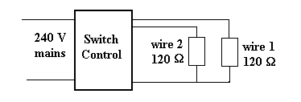
- If only wire 1 is connected to the 240 V supply, what is the current from the supply? (2 mark)

- If wires 1 and 2 are connected in series, what is the current drawn from the supply? (2 marks)

- If wires 1 and 2 are connected in parallel, what is the current drawn from the supply? (2 marks)

- Explain how the electric blanket can be operated on different heat settings. (2 marks)
_____________________________________________________________________________
_____________________________________________________________________________
__________________________________________________________________________________________________________________________________________________________
- Draw a circuit that has two 50 Ω resistors in parallel with each other. A 20 Ω resistor is in series with one of the 50 Ω resistors within the parallel section. A 100 Ω resistor is in series with the parallel. An ammeter is set up to measure the current through the whole circuit and a voltmeter is set up to measure the potential difference across the 20 Ω resistor. A 12 V power pack is used to run the circuit. Draw the circuit. (3 marks)

10. A student completes a circuit that includes a mystery box as shown below.
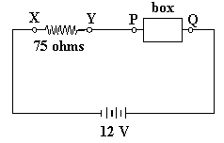
If the potential difference between X and Y is 9.0 volts, which of the following boxes (A - D) is in
the circuit? (3 marks)

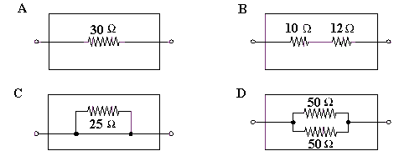

Answer

11. Three resistors, having resistances of 20 Ω, 30 Ω and 50 Ω are connected in series across a 12 V power supply. Calculate
a. The total resistance. (1 mark)

b. The current flowing in each resistor. (1 mark)

c. The potential difference in the 30 Ω resistor. (1 marks)

The resistors are then connected in parallel. Find
d. The total resistance. (2 mark)

e. The current through the 30 Ω resistor. (2 marks)

- An electrical engineer has set up the following circuit in an electrical device. By showing your working below and writing your answers in the spaces provided:

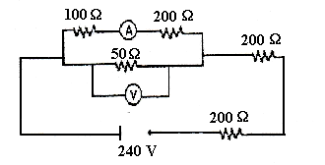
- Determine the total resistance of the circuit. (2 marks) Answer: __________________
b. What is the reading on the voltmeter? (3 marks) Answer: __________________
c. What is the reading on the ammeter? (2 marks) Answer: __________________

BONUS QUESTION.
Do not attempt this question until all the others are answered. Bonus question is worth 5 marks.

To the nearest 10 ohms, what is the value of the unknown resistor? The current in the 150 Ω resistor is 0.11834 A.

